The document information was taken from the Canvas Student Guide. – M. Lion

How do I add multiple files to my Assignment submission?
You can upload multiple files to your submission.
Note: Each user has 250 MB of storage space in Canvas. Personal files include profile pictures, uploaded assignment submissions, and other files uploaded to your personal Canvas file storage area. If you delete a file that you submitted as an assignment in your personal storage area, it will not delete the assignment submission in the course.

Open Assignments
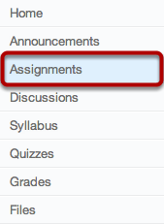
Click the Assignments link.

Select Assignment
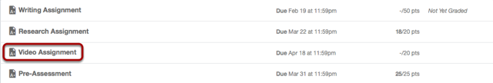Zoom
Select the assignment you want to upload the files to by clicking on the assignment title.

Submit Assignment
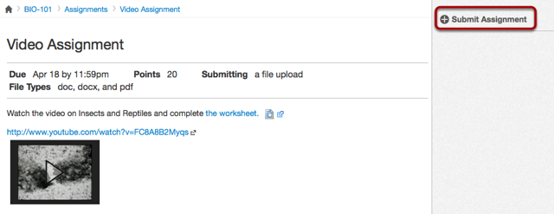Zoom
Add a file to the assignment by clicking the Submit Assignment link.

Browse for File
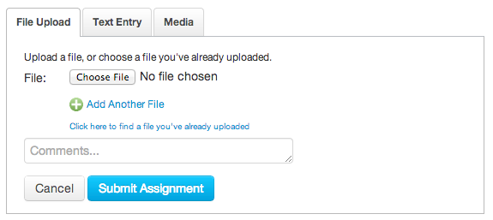
Click the Choose File button to select the file you would like to upload.
Note: You can only submit one file type per assignment submission. You cannot change the submitted file type unless you re-submit the assignment.
Note: You may see Browse depending on the browser you are using.

Select File
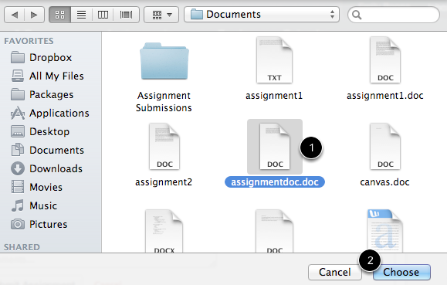
Click the file you would like to upload [1] and click the Choose button [2] to upload the file.
Note: You may see an Open button instead of Choose.

Add Another File
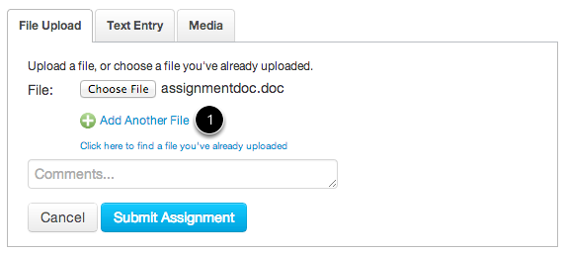
Click the Add Another File link to upload additional files to your assignment. You will just need to repeat the above steps to add another file. You can also find a file you've already uploaded to use as a submission.

View Multiple Files
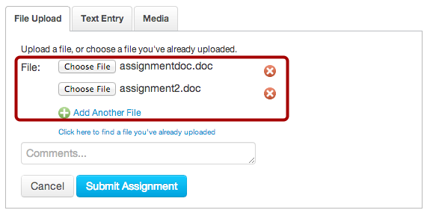
Multiple files will appear if you add another file.

Submit Assignment
Click the Submit Assignment button to submit your assignment.

View Submitted Assignment
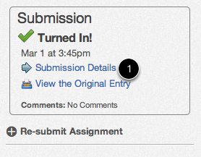
You can view your submitted assignment by clicking the Submission Details

