Major Project 5 - Podcasting – 150 Points

Purpose & Introduction. Thus far in K200 you have been working out of a textbook or a handout following step-by-step instructions. This helped you learn skills in creating and editing audio and video files. This major project will test your ability to apply the skills you have learned and your own creativity. Although the below project may give you some step-by-step instructions, you will need to use your own creativity and problem-solving skills to create the podcast. For this project you will create Lastname_Firstname_History_of_Olympics.mp3 in Audacity.

Student Data Files. You will find the needed assignment files on the All Project Due Dates Webpage listed under Major Project #5 - Podcasting.

The files are:
- Audacity folder:
    - olympic_discussion.aup3
- Free Music folder:
    - Vanessa_Van_Spall_-_Save_Me.mp3
    - Vittoria_Conn_-_Dont_Say_It.mp3
    - Zoe_Blade_-_Bondi_01.mp3

Submit for Grading. Your podcasts must be put in your Major Project #5 – Podcasting section of Assignments in Canvas by 11:59 Sunday, April 14, 2024. Yes it is a different due DAY than other major projects. If your work is not in the correct Canvas section on time, it will not be graded. Yes losing 150 points will hurt your grade.

Files to be submitted:
- Lastname_Firstname_History_of_Olympics.mp3
- Lastname_Firstname_History_of_Olympics.aup3

This project is worth 150 points.

TASKS: Lastname_Firstname_History_of_Olympics.mp3

Audio Podcast – History of the Olympics
Assess Skills: 1.) Create new file in Audacity; 2.) Create a fade-in and fade-out; 3.) Delete excess music clip; 4.) Import audio file into Audacity; 5.) Convert .aup3 file to .mp3 in Audacity.

Before you begin: Work through Introduction to Podcasting manual.
You will need to create a podcast about the history of the Olympics. You will name the podcast Lastname_Firstname_History_of_Olympics. You will use the file, olympic_discussion.aup3, found in the Audacity folder. The history of the Olympics is discussed in the first half of the file. You must edit out the part of the audio file that focuses on politics. Podcast should only have introduction of interview and interviewee and the history of the Olympics. Add music from the supplied files in the Free Music folder for a fade-in at the beginning of the podcast and a fade-out at the end.

Note: YOU MUST USE THE MUSIC PROVIDED TO YOU IN THE FREE MUSIC FOLDER!!! You are only allowed to use this music. Use of any other music will result in losing all points for this part of Major Project 5.

Proposed Work Flow:
- Open Audacity.
- Open the Audacity file olympic_discussion.aup3.
- Listen to the entire file.
- Edit the file so that only the parts that introduce the speakers and those parts covering the history of the Olympics can be heard. Delete other parts.
  - Hint: You will hear Ms. Lion say “Speaking of politics…” somewhere between 6 and 6:30 minutes. Cut from that sentence to the end of the audio clip. This is all you will need to do.
- Save project as Lastname_Firstname_History_of_Olympics.
- Pick a song from the Free Music folder and add it to the Audacity project. The song is your choice.
- Song Fades: REMEMBER WHAT THEY LOOKED LIKE AND HOW YOU MADE THEM IN THE WEEKLY PROJECT! MUST BE THE SAME HERE!
  - At the beginning of the track there must only be music NOT voices and music.
  - The song must fade-in and fade-out at the beginning of the podcast and fade-in and fade-out at the end.
  - Both the beginning and the end fading music clips should be between 4-10 seconds. You get to decide. Note: Create the fade-in and fade-outs like you did in the Weekly Project.
  - Note: One music file will not be long enough to cover the entire song and then be used as a fade-out. This is where you will use copy and paste from the weekly project.
  - Note: You will need to move the interview clip so that you can have a fade-in/fade-out at the beginning and end. Refer to Introduction to Podcasting manual if you need help remembering how to do this.
  - The music should not be heard during the interview. Yes, you might hear a bit due to the fade-in and fade-out at the beginning and the end. However, you should not hear the music during the interview.
  - At the end of the track there must only be music NOT voices and music.
- Save your work.
- Convert your work to an .mp3 file. Make sure to put your name in the artist text box and the current year in the year text box. Your Metadata Tags should look similar to the picture below. You do NOT need to fill in the Comments. If the software has updated, and there is a new field, you can fill it in or not as you see fit.

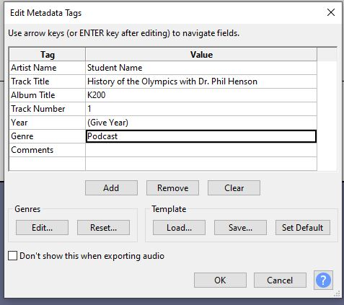

- File name must be: Lastname_Firstname_History_of_Olympics.mp3
- Make sure your file is between 6:30 and 7 minutes in length.
- You should now have to audio files:
  - Lastname_Firstname_History_of_Olympics.aup3
  - Lastname_Firstname_History_of_Olympics.mp3
- Save both files to Podcasting folder in OneDrive.
- Submit both audio files for grading: Lastname_Firstname_History_of_Olympics.mp3 and Lastname_Firstname_History_of_Olympics.aup3 to the Major Project # 5 – Podcasting section of Assignments.
- VERY IMPORTANT - PAY ATTENTION: YOU MUST submit both files!

Criteria for Success: Grading Rubric:
- Music opens podcast, fading in and out: (-10 if incorrect/cannot hear for either)
  - Only music is heard for the beginning fade-in. Remember how it sounded in Weekly Project.
  - Only music is heard for the ending fade-out. Remember how it sounded in Weekly Project.
- Music chosen from provided files. (-10 if incorrect)
- Music is not heard during the interview. (-10 if incorrect)
- Podcast has introduction of interviewer and interviewee. (-10 if incorrect/cannot hear)
- Must hear Lion and Henson voices. (-10 if incorrect/can’t hear)
- Podcast gives history of the Olympics. (-10 if incorrect/can’t hear)
- Music ends podcast, fading in and out. Voices go away during the fade-out. Remember how it sounded in Weekly Project. (-10 if incorrect/can’t hear)
- File should NOT be longer than 8 minutes. (-10 if incorrect)
- Metadata Tags are similar to above picture. (-10 if incorrect)
- Podcast has file name: Lastname_Firstname_History_of_Olympics.mp3. (-10 if incorrect)
- You have submitted both audio files: Lastname_Firstname_History_of_Olympics.aup3 and Lastname_Firstname_History_of_Olympics.mp3. There MUST be both file types. No, you will not be able to submit the missing file after the due date. (-75 if missing either file type)
- Submitted to Major Project #5 – Podcasting in Assignments. (-150 if not done)

